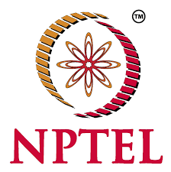**GEETHAKRISHNA PULIGUNDLA**

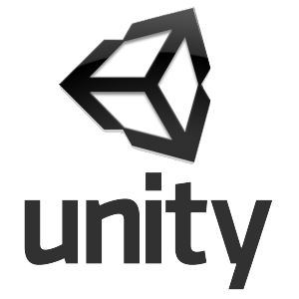

[PGEETHAKRISHNA@GMAIL.COM] [+919666308802]

**CAREER OBJECTIVE:**

As a Fresher, I want to utilize my skills & technologies with which I am familiar with, and it will help your organisation and also help me in building my professional career.

**EDUCATIONAL QUALIFICATION:**

* Pursing B.tech in Computer Science Engineering at Annamacharya institute of technology and sciences, Tirupati with an aggregate of 81.9 % (up to 3-2). [JUNE 2016- MAY 2020]
* Completed XII at Bhashyam IIT-JEE Academy, Tirupati with an aggregate of 93.1%.

[JUNE 2014-APRIL 2016]

* Completed SSC at Bhashyam High School, Tirupati with a GPA of 9.7.

[JULY 2009–MAY 2014]

**TECHNICAL SKILLS:**

* **Programming Languages :** C, Java
* **Query Language :** SQL
* **Web technologies :** HTML, CSS
* **Software Packages :** UNITY, VS Code, Adobe Photoshop CC
* **Cloud Services :** Amazon Web Services(AWS)

**ACHIEVEMENTS:**

* Got **Elite** Certification on **“Problem Solving through C”** by NPTEL.
* Done Certification on **AWS Technical Essentials**.
* Shortlisted for South India zone VR workshop by **SV.CO,** in collaboration with the **Facebook school of Innovation (India).**
* Attended for a workshop on **“Entrepreneur workshop”** by **i2e** in partnership with **Northeastern University, Boston USA.**

**INTERNSHIPS:**

Attended for summer Internship in **“Indian Game Development Challenge”** and designed a game called **“Unlocking-Strain your Brain”** organised by APSSDC in collaboration with KAMK University, Finland. [JUNE&JULY-2018]

**PARTICIPATIONS:**

* Presented a paper on **“Network Security”** in Mohanamantra2k17 at Shree Vidyanikethan College.
* Participated in Coding competition in Tirutsava at IIT Tirupati.
* Attended for a workshop on **“Entrepreneurship & Emerging Technologies”** by **IBhubs**.
* Attended for a Meet-Up on Blogging, namely **“AllIndiaDigitalSkillMission”** by the crew of India’s most popular Bloggers.

**EXTRA CIRICULAR ACTIVITIES:**

* Student Coordinator in technical Fests.

I)Event Organizer for Lorecron2k19.

II) Student coordinator for TechnoSangraam2k18 and Technosangraam2k19.

* NSS volunteer
* Social help Initiator and provider.
* Acted as Police Volunteer during Bramhosthavams in Tirumala under the team of Tirupati urban police.

**MINI PROJECTS:**

* **1. UNLOCKING - Strain Your Brain**

**Abstract:** Unlocking is a Puzzle game. The idea behind the game is based on the Android Pattern Lock System. It Reflexes Your Sharpness and concentration level of your brain. It has **1000+** downloads in play store.

Technical Environment: Unity

* **2. Festival Greetings Website**

**Abstract:** It is a website which wishes the people who opens it.

Technical environment: Visual Studio

**PERSONAL DETAILS:**

* Father name : Ramesh P
* D.O.B :13-DEC-1999
* Address : 8-84/15,Gandhipuram,Tirupati
* Languages : English, Telugu, Hindi

**DECLARATION:**

I hereby declare that above furnished particulars are true to the best of my knowledge and belief.

Place : Signature

Date : [GeethaKrishna P]